SPRING-38 – API GATEWAY

Create a new application for api gateway with following dependencies:

<dependency>  
 <groupId>org.springframework.cloud</groupId>  
 <artifactId>spring-cloud-starter-gateway</artifactId>  
</dependency>  
<dependency>  
 <groupId>org.springframework.cloud</groupId>  
 <artifactId>spring-cloud-starter-netflix-eureka-client</artifactId>  
</dependency>

We have used eureka here so as to call the services by their names.

Properties file route mapping:

spring.cloud.gateway.routes[0].id=config-client  
spring.cloud.gateway.routes[0].uri=lb://SPRING-CONFIG-CLIENT-APPLICATION  
spring.cloud.gateway.routes[0].predicates=Path=/service2/\*\*  
  
spring.cloud.gateway.routes[1].id=batch-application  
spring.cloud.gateway.routes[1].uri=lb://SPRING-BATCH-APPLICATION  
spring.cloud.gateway.routes[1].predicates=Path=/service1/\*\*

we hit gateway application and depending on the path in url, the request will be routed to the appropriate applications:

hit config-appl 1:

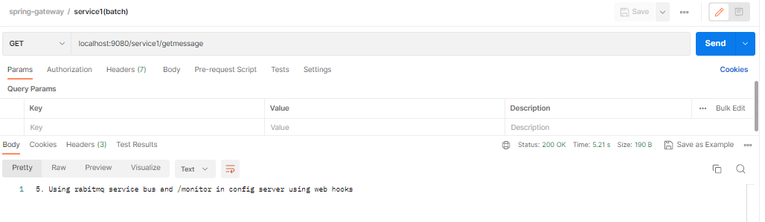

Hit config-appl2:

